Stage pipeline creation

Step 1. <build>
<finalName>zenpolicies-service-talent</finalName>
<plugins>
<plugin>
<groupId>org.springframework.boot</groupId>
<artifactId>spring-boot-maven-plugin</artifactId>
<configuration>
<mainClass>com.zensar.zenhelp.ZenpoliciesServiceZentalentApplication</mainClass>
<addResources>true</addResources>
</configuration>
</plugin>
</plugins>
</build>

final name and main class tag should be there.

Note:
Add docker file
having

FROM jdk-1_8_201:base
ADD target/exit-service-talent.jar /exit-service-talent.jar
ENTRYPOINT ["/usr/bin/java"]
CMD ["-jar", "/exit-service-talent.jar"]
EXPOSE 67

Step 2.
Jenkins ----> New Item ---->make folder ZenFinance_ZenTalent
make

Step 3.
Click on New Item ----> choose freeStyle project -----> folder name shuld be like zenfinance

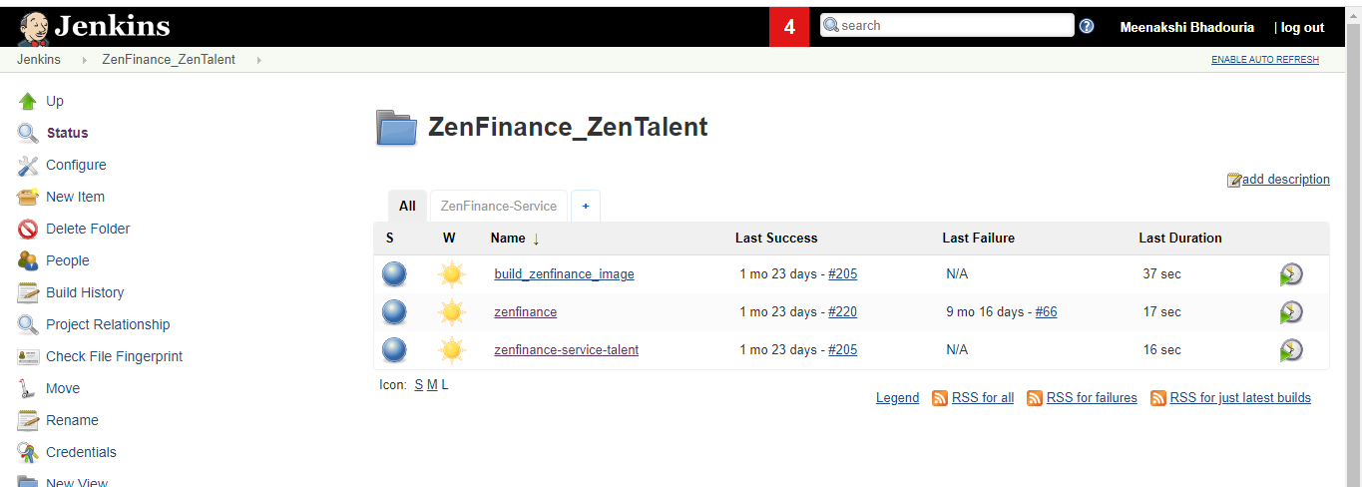

First free style project that is zenfinance will perform below operations

In this step we are taking checkout of the project from the SVN repository to our Jenkins server and
then we are creating jar by maven mvn clean install command .
After creating the jar file from the project, we are copying the jar file and the docker file to the particular servers where we have to deploy our services.
Then we have to give our post build action.

Below are the steps

For adding svn details like url and credentials

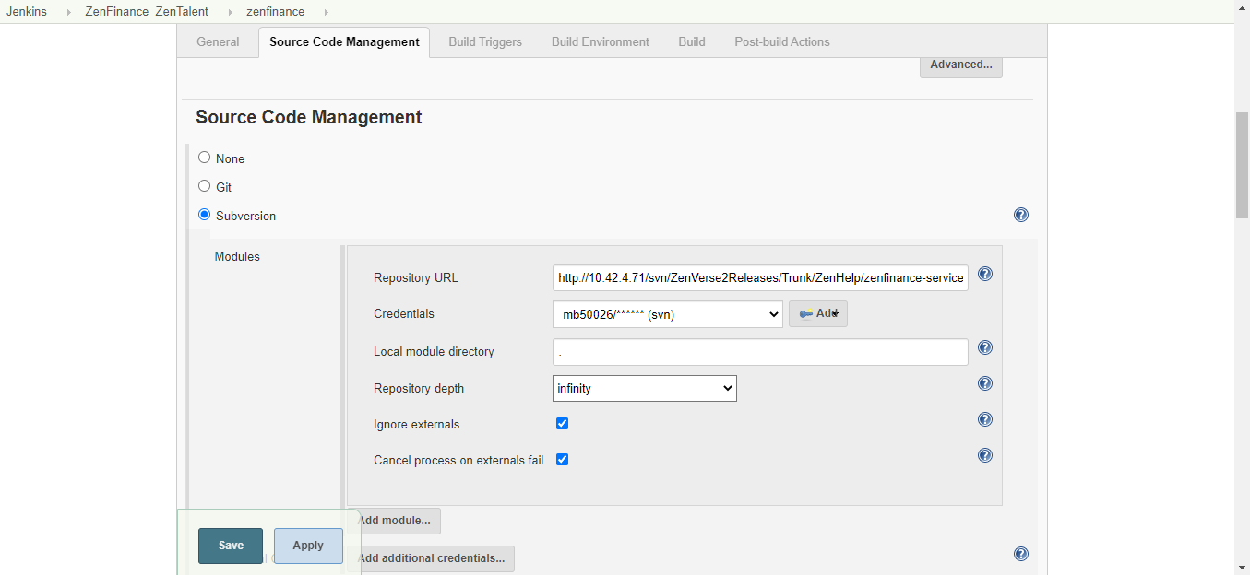

For creating jar file and writing shell scripting command to copy the jar file and docker file to server
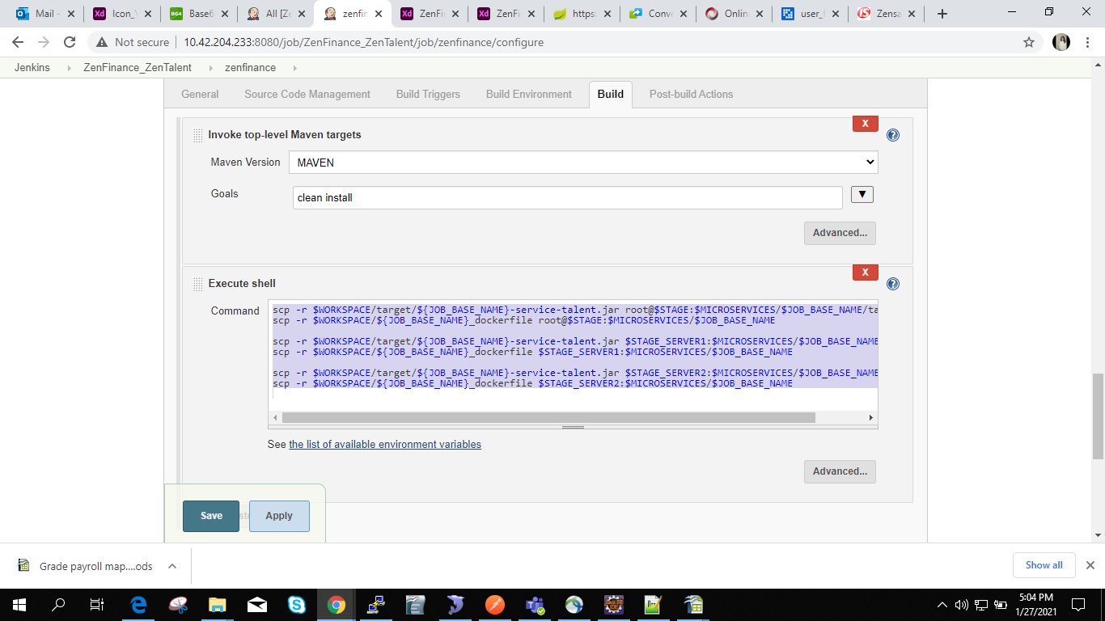

scp -r $WORKSPACE/target/${JOB_BASE_NAME}-service-talent.jar root@$STAGE:$MICROSERVICES/$JOB_BASE_NAME/target/
scp -r $WORKSPACE/${JOB_BASE_NAME}_dockerfile root@$STAGE:$MICROSERVICES/$JOB_BASE_NAME

scp -r $WORKSPACE/target/${JOB_BASE_NAME}-service-talent.jar $STAGE_SERVER1:$MICROSERVICES/$JOB_BASE_NAME/target/
scp -r $WORKSPACE/${JOB_BASE_NAME}_dockerfile $STAGE_SERVER1:$MICROSERVICES/$JOB_BASE_NAME

scp -r $WORKSPACE/target/${JOB_BASE_NAME}-service-talent.jar $STAGE_SERVER2:$MICROSERVICES/$JOB_BASE_NAME/target/
scp -r $WORKSPACE/${JOB_BASE_NAME}_dockerfile $STAGE_SERVER2:$MICROSERVICES/$JOB_BASE_NAME

Step to define post build action

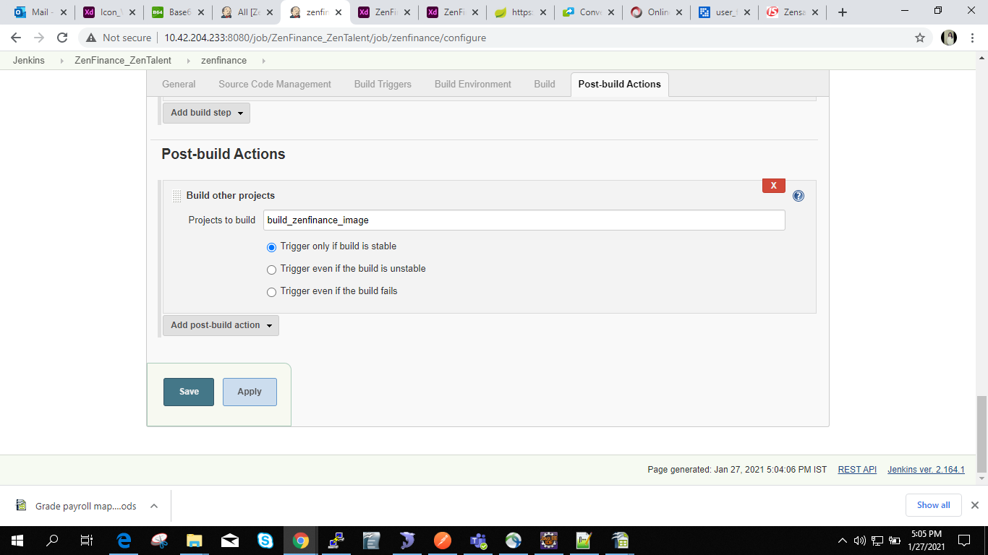

Step 5.
Click on New Item -----> make folder choosing freestyle project name like build_zenfinance_image

In this freestyle project , we will generate docker image from the docker file

Below command will check if the docker image with name for example zenfinance-service-talent:latest
is present or not if its already there , it delete the image and create a new image with tag latest
like zenfinance-service-talent:latest will be generated at particular server.

We have to mention the location where we have kept our docker file.

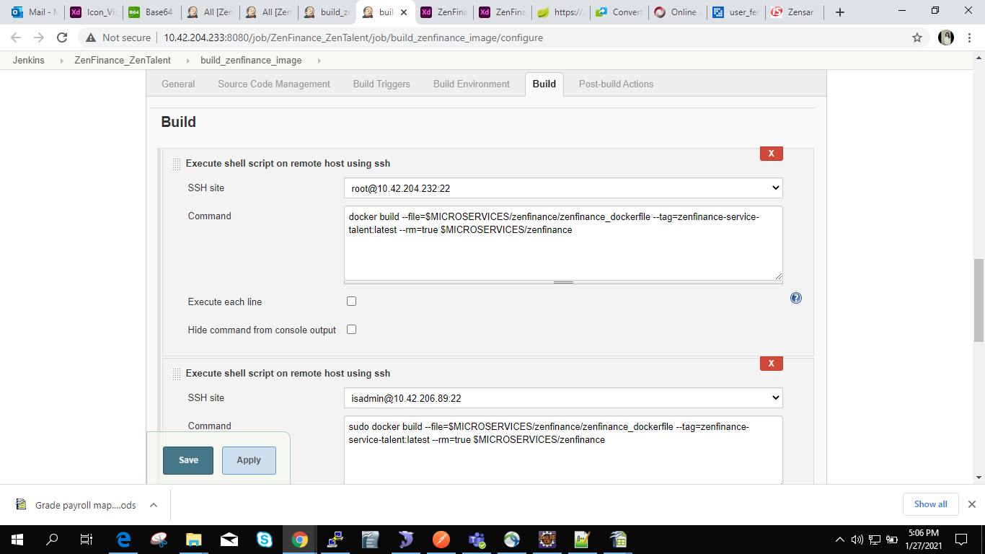

then
paste
docker build --file=$MICROSERVICES/zenfinance/zenfinance_dockerfile --tag=zenfinance-service-talent:latest --rm=true $MICROSERVICES/zenfinance

isadmin@10.42.206.89:22
sudo docker build --file=$MICROSERVICES/zenfinance/zenfinance_dockerfile --tag=zenfinance-service-talent:latest --rm=true $MICROSERVICES/zenfinance

isadmin@10.42.206.90:22

sudo docker build --file=$MICROSERVICES/zenfinance/zenfinance_dockerfile --tag=zenfinance-service-talent:latest --rm=true $MICROSERVICES/zenfinance

Then Post build action

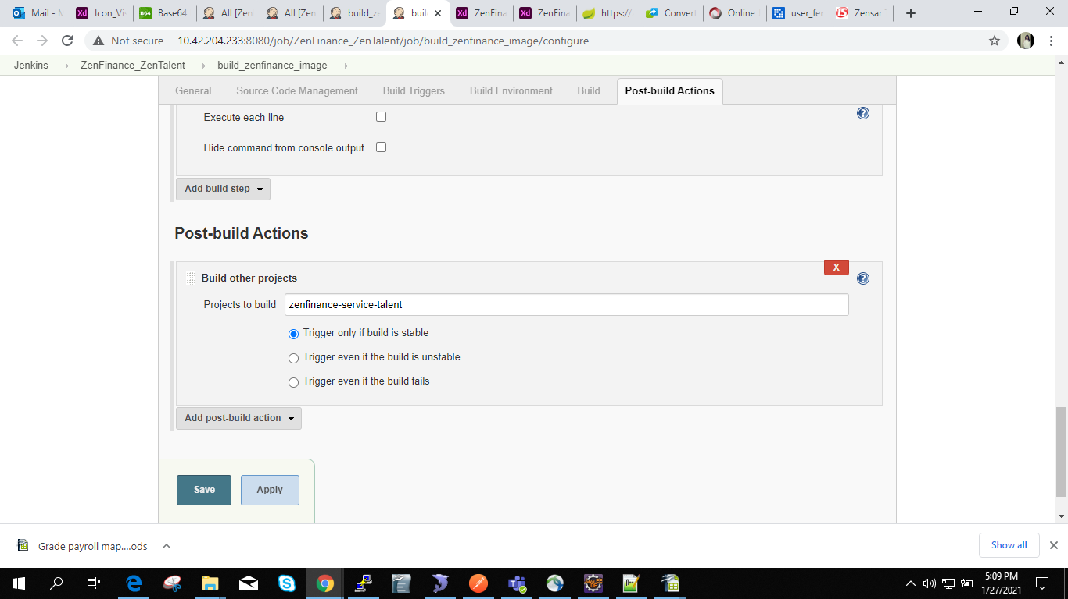

Step 6.

New Item -----> freeStyleProject folder name should be like zenfinance-service-talent

In this step we run our docker image to the servers, below are the command we used to run our docker image

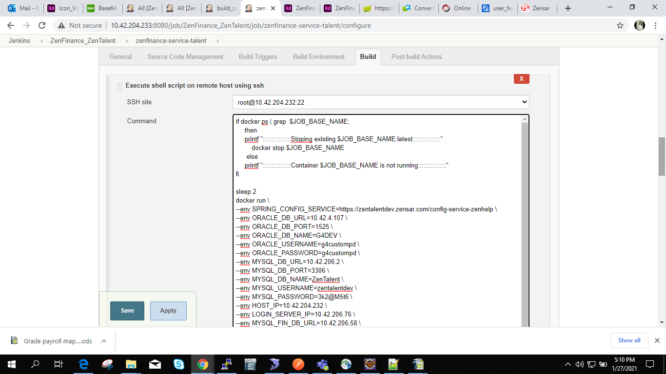

Set Environment variables for all servers

if docker ps | grep $JOB_BASE_NAME;
then
printf "::::::::::::::::Stoping existing $JOB_BASE_NAME:latest::::::::::::::::"
docker stop $JOB_BASE_NAME
else
printf "::::::::::::::::Container $JOB_BASE_NAME is not running::::::::::::::::"
fi

sleep 2
docker run \
--env SPRING_CONFIG_SERVICE=https://zentalentdev.zensar.com/config-service-zenhelp \
--env ORACLE_DB_URL=10.42.4.107 \
--env ORACLE_DB_PORT=1525 \
--env ORACLE_DB_NAME=G4DEV \
--env ORACLE_USERNAME=g4custompd \
--env ORACLE_PASSWORD=g4custompd \
--env MYSQL_DB_URL=10.42.206.2 \
--env MYSQL_DB_PORT=3306 \
--env MYSQL_DB_NAME=ZenTalent \
--env MYSQL_USERNAME=zentalentdev \
--env MYSQL_PASSWORD=3k2@M5t6 \
--env HOST_IP=10.42.204.232 \
--env LOGIN_SERVER_IP=10.42.206.76 \
--env MYSQL_FIN_DB_URL=10.42.206.58 \
--env MYSQL_FIN_DB_PORT=3306 \
--env MYSQL_FIN_DB_NAME=ZenCFO_DEV \
--env MYSQL_FIN_USERNAME=am46186 \
--env MYSQL_FIN_PASSWORD=mX827#Tx \
-d -e "TZ=Asia/Kolkata" -v /upload:/upload --rm=true --name=$JOB_BASE_NAME --publish=69:69 $JOB_BASE_NAME:latest

printf ":::::::::::::::::::::::::check log file $DOCKER_LOGS for $JOB_BASE_NAME::::::::::::::::::::::::::::"

docker logs $JOB_BASE_NAME --follow >> $DOCKER_LOGS/$JOB_BASE_NAME.log 2>&1 &

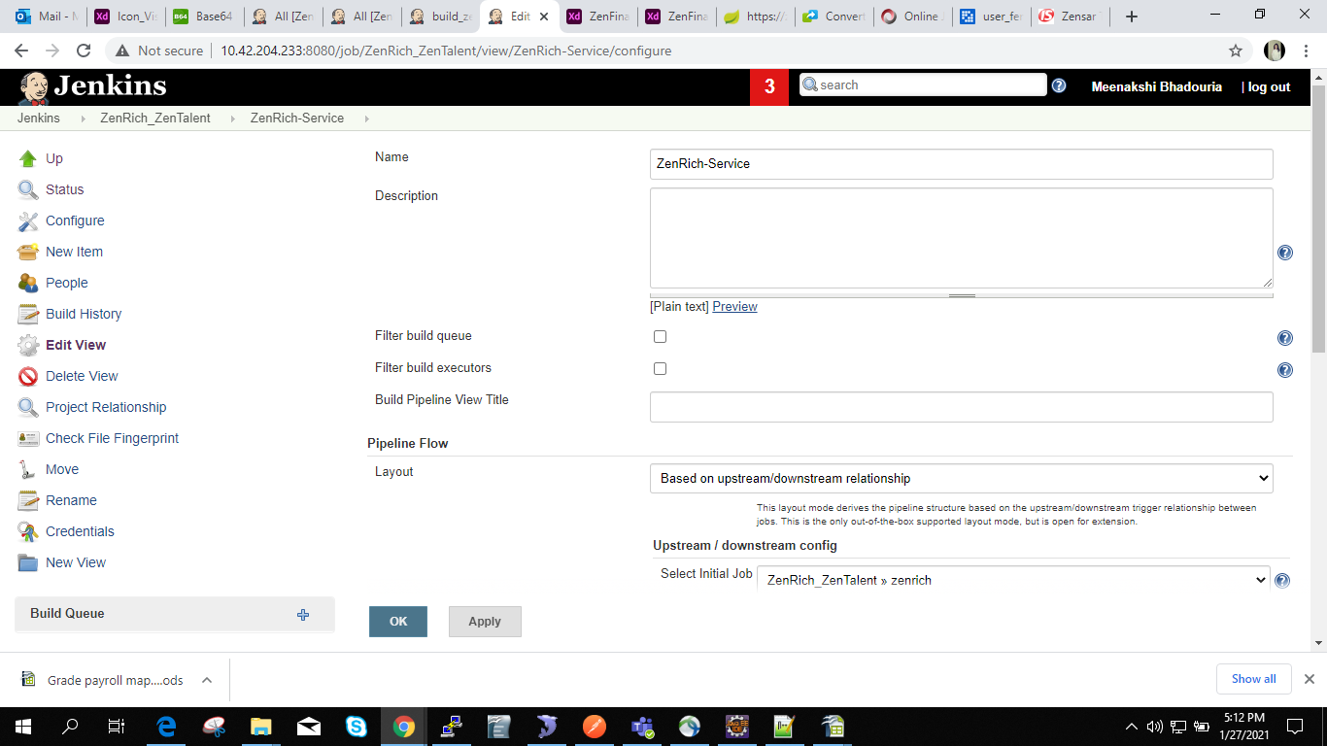
For Creating Jenkins pipeline

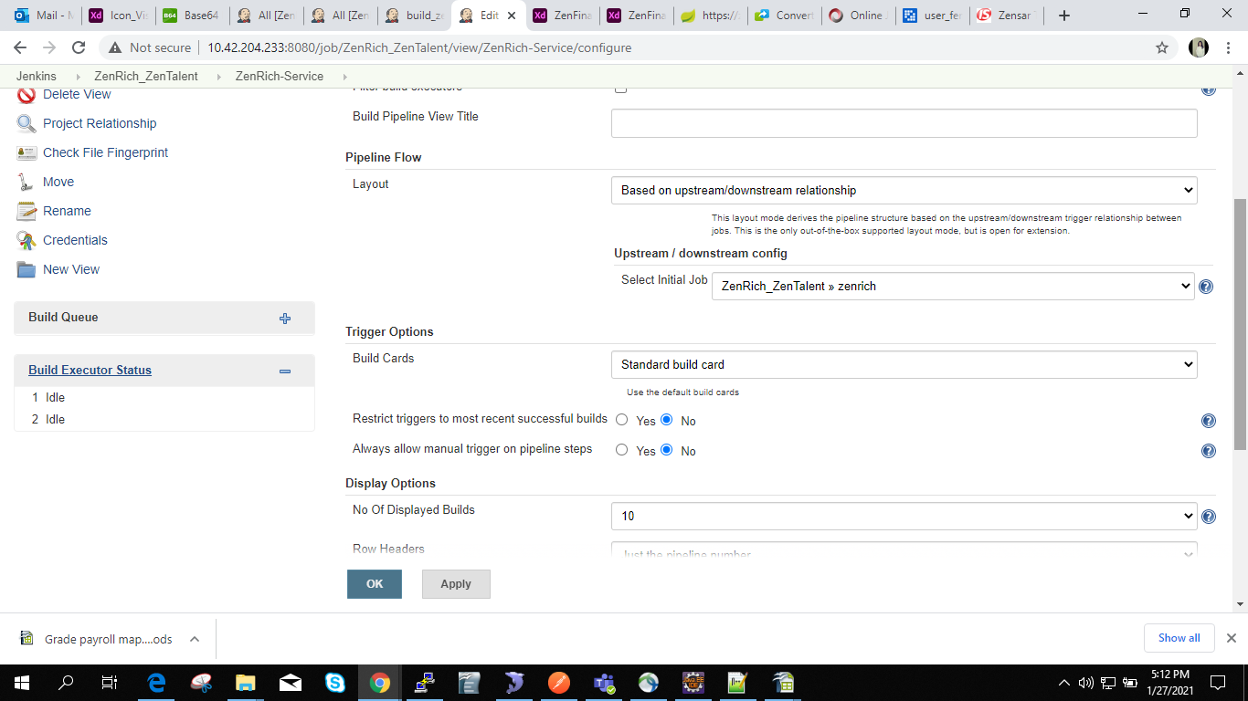

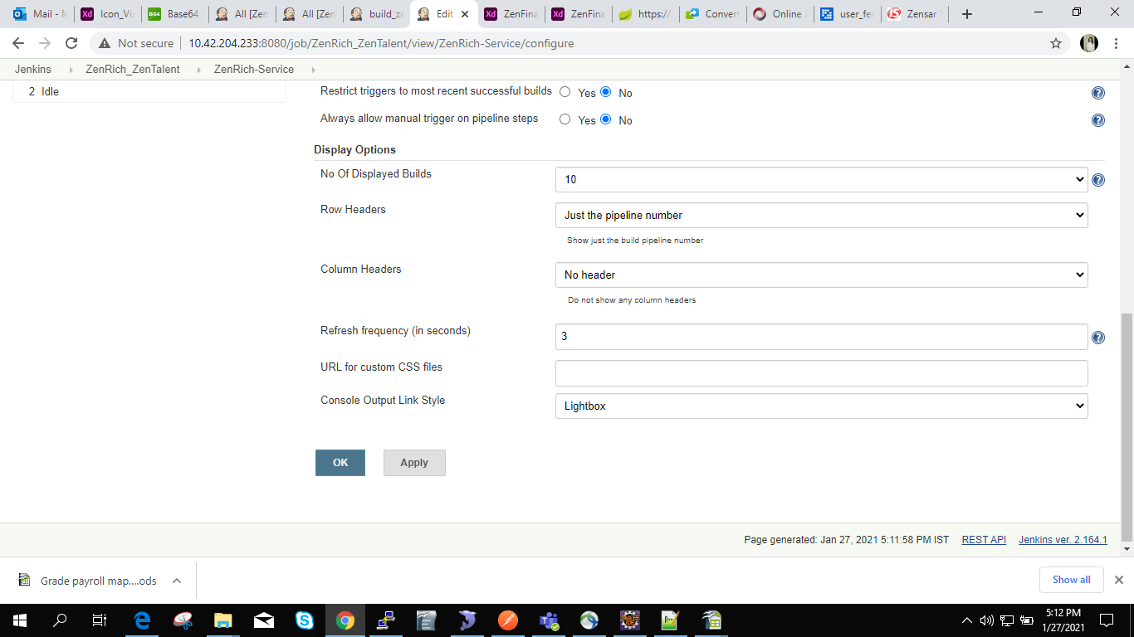

NOTE: /usr/local/microservices/ZenHelp at this location make folder like zenrich / zenfinance

